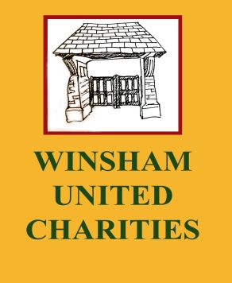
Registered Charity number: 234867
WUC Grant Application Form
Winsham United Charities will consider requests, from young people living in the Parish of Winsham, for help with the costs of: equipment; tuition; events; activities; and travel expenses. WUC cannot provide retrospective grants. Funding is for families and individuals in need. The trustees do not want any young person to be negatively disadvantaged through hardship. Most requests for funding are dealt with within 4 weeks and are for sums varying between £20 and £200. The decision of the WUC Trustees is final and no correspondence concerning grants will be entered into.

Full Name:……………………………………………………………………. Date of birth:……………………………………………..
Address:…………………………………………………………………… Signature:……………………………………………………
Amount of grant applied for:…………………………………………
Purpose of the WUC grant: In the box below, please outline how you will use the grant and any further details you feel important in support of your request. (Continue overleaf if necessary)
Purpose of the WUC grant:

This application form should be emailed to: winshamunitedcharities@gmail.com
or sent to: The Trustees WUC, c/o The Clerk to the Parish Council, Jubilee Hall, Church Street, Winsham, Chard, Somerset, TA20 4HU.

